*AIR CANVAS AND VIRTUAL COMPUTER SYSTEM*

1Darshan Patel 2Harshitha Moolya

Computer Engineering Computer Engineering

SIES Graduate School of Technology SIES Graduate School of Technology

Navi Mumbai, India Navi Mumbai, India

darshan.chandulal18@siesgst.ac.in [moolya.harshitha18@siesgst.ac.in](mailto:moolya.harshitha18@siesgst.ac.in)

3Kriti Kakkar 4Masooda Modak

Computer Engineering Computer Engineering

SIES Graduate School of Technology SIES Graduate School of Technology

Navi Mumbai, India Navi Mumbai, India

kriti.kakkar16@gmail.com masooda.modak@siesgst.ac.in

***Abstract*—**This paper explains how to draw and write English text in front of a camera using a real-time video-based pointing technique. To achieve the purpose, the proposed system combines color recognition and tracking to track the coloured finger tip in video frames. A mask is formed when a color marker is detected. It includes two stages of the morphological process. Erosion and Dilation are two procedures performed on the mask. Impurities are reduced through erosion present in the mask, and dilation helps to repair the primary mask's deteriorated condition.The user will even be able to select the colors that will be shown in the suggested system. The camera will be triggered when the programme is started, allowing the user to draw in the air just by waving the tracker item. The artwork is also visible on the white window at the same time. Instructor can choose any color of his choice displayed in the system’s color palette to draw and also can clear the screen when needed. We will be using the computer vision techniques of opencv and python to build this application Also, our system includes virtual keyboard and virtual mouse.The proposed framework for virtual keyboard is vision-based, and it makes use of AI technologies as well as input from a PC webcam.The Virtual Mouse detects finger movements to control the cursor using basic motions and hand control without the need for extra hardware. This is accomplished by combining webcam inputs with vision-based hand gesture detection. We intend to develop a full-pledge app which will include all these features.

***Keywords—opencv; color recognition; morphological process; virtual computer system; erosion; dilation ;tracking; computer vision***

# I. INTRODUCTION

In the era of the digital world, traditional art of writing is being replaced by digital art. Digital art refers to forms of expression and transmission of art form with digital form.Air Canvas is a hands-free digital drawing tool that uses a technique of AI based components like OpenCV to paint on the screen.In air canvas we can draw anything on the screen with only waving your finger around in the air or using a virtual pen by the technique of contour detection based on the mask of the desired colored target marker.In our project, we also attempted to control mouse cursor movement, keyboard control and click events using a color detection approach based on a camera. It's a system that performs image processing, retrieves needed details, and then adds them to the computer's mouse and keyboard interface using pre-defined notations.Our system also focuses on Volume

Control through Gesture Recognition using the same logic as

mentioned above for virtual mouse.

# II. LITERATURE SURVEY

This section includes all the techniques involved in literature for air canvas virtual mouse and virtual keyboard.

In paper[1],the project is a reporter of occasional gestures. It used pc imaginative and prescient to hint the direction of the finger. The generated textual content became used for diverse purposes, together with sending messages, emails, etc. It could be an effective method of communique for the deaf. It is a powerful communique technique that reduces cell and pc utilization via means of casting off the want to write. Use of character Recognition is time-consuming and Complex

The suggested system in paper[2] comprises various stages. It follows the movements of a coloured finger tip, calculates its coordinates, and plots them. Following the charting of coordinates, optical character restructuring (OCR) is applied to the plotted image, the output is matched with an OCR trained database, and the best match is attained and displayed. The suggested approach is color sensitive, which means that any red color in the backdrop before commencing the analysis can cause erroneous findings.

Image processing and feature extraction were the foundations of the paper [3]. The OpenCV package was used to track an object of interest (in this case, a bottle cap) and allow the user to draw by moving the object, which makes drawing basic things both fantastic and tough.The suggested system has a limited use; it can only be used to sketch and has no built-in shapes or other features.

In paper[4] the authors have used hand gestures to implement virtual mouse.The virtual mouse establishes a virtual connection between the user and the machine without the usage of any hardware. This gesture recognition system can capture and track the fingertips of a person wearing a color hat with a webcam, which recognizes the hand's color and movements and moves the cursor along with it. The majority of applications necessitate the purchase of additional hardware as well as a specialized operating system, both of which can be costly.

The project code in paper[5] makes use of emguCV, a.NET wrapper for openCV, a well-known image processing programme. The application looks for a video input device first and foremost. If it succeeds, the function ProcessFramAndUpdateGUI() is called, which completes the processing. The technology will not be able to eliminate the need for a mouse and keyboard entirely. The purpose of this project is to construct an interactive computer system that can be used without a mouse or keyboard.

In paper[6], the purpose of research is to develop a computer application that uses various approaches to manage keyboard and mouse cursors to assist people who have had a stroke in recovering from the consequences of the stroke. The system may be less accurate in low-light circumstances. In addition, the research can be applied to a variety of scenarios and tested using advanced current models.

In paper[7] ,an application is made where a webcam stares down on a user's hands, which are resting on a paper keyboard template in this setup. The programme uses camera photos to figure out when and where the user touches the keyboard template. When the user presses a key, the application outputs the letter that corresponds. Fingertip identification is difficult. When two fingers are combined into a single zone or one finger occludes another, the system fails to give consistent results.

In paper[8], the authors have used DIP to carry out the implementation. A projector was used to project the picture of a keyboard, and a camera was used to capture the image. The image acquired by the camera is processed by the processor. Frame extraction was the goal of.NET platform applications. Only a single touch is supported in this implementation.

The virtual keyboard suggested in paper[9] employs a novel way to recognise letters based on the user's touching gestures.When the coordinates are changed to a different image of a keyboard, this approach fails.

# III. PROPOSED SYSTEM

This System will provide modules like Air canvas where the presenter can write, draw different shapes and explain concepts without the use of pen and board, virtually on the space being captured in the camera frame. Similarly, the feature of virtual mouse and keyboard will aid in accessing and operating application free handedly.User would be able to perform mouse and keyboard operation virtually with the hand movements which will be recognised as hand Gesture by the system software. The best part is this virtual classroom/ meeting doesn't need a separate structure to hold meetings. It can be done anywhere and anytime.

Our system will provide the following set of objectives as listed below:

* 1. To create a virtual canvas to sketch,perform morphological operations and to also include different types of shapes so that the user can directly use them by picking and dragging them virtually.
  2. To implement Virtual Keyboard.
  3. To include Virtual Mouse system.
  4. To develop a full-pledge app in order to make use of this amazing tool.

IV. SYSTEM DESIGN

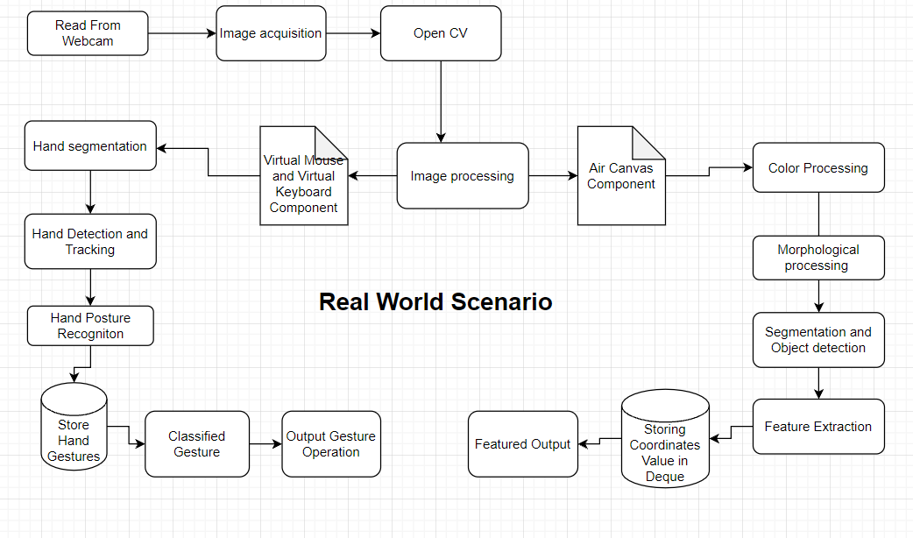

Fig. 4.1. System Design for Air Canvas

The above fig.4.1 shows the overall system design architecture of our proposed system. The figure demonstrates the different steps and various important components involved in the design of Air Canvas and Virtual Computer System .

Our very last recreation includes a general of 3 components which in general make contributions to our project. These components are explained one by one below with their proper system diagram as follows:

A. AIR CANVAS **:**Using Air Canvas, you can draw anything on screen by just capturing the action of a hand’s fingertips with the help of a camera. We have used a hand tracking module to track the fingertips of the hand. To create this project, we will use OpenCV's computer vision methods. A mask is created once the hand is identified. Erosion and Dilation are two further morphological procedures on the mask that are included in this stage. Erosion lowers contaminants in the mask, and dilation restores the damaged primary mask even more. We have also given various color options like shades of blue, red, yellow and green. It also includes a clear option to clear the screen.We will also add different types of shapes like a circle, triangle, rectangle, square into it so that the user can directly pick them and drag it on the screen.

B. VIRTUAL KEYBOARD: We plan to develop a virtual keyboard which will help us in typing without the need of a physical keyboard.There would be a keyboard displayed on the computer screen, created using different GUI components. Users can start typing without actually touching it. It is different from the ones we use in our smartphones. Camera will start taking input. After detecting our hands,it will actually keep a track of hand movements.If the finger of the user is over a specific key and the distance between thumb and forefinger is less than a specific distance then that key will get pressed.

C. VIRTUAL MOUSE: Along with a virtual keyboard, we have also planned to include a virtual mouse system which will make the entire system a virtual computer system where you don’t need any actual keyboard and mouse, just a monitor. This virtual mouse will use hand

gestures to perform various actions and can be used to access the functionality of the Air Canvas and Virtual Keyboard . We will first detect the hand landmarks and then track and click based on these points. We will also apply smoothing techniques to make it more usable. The camera recognizes the finger movements and performs actions based on it. An Index finger Up can be used to move the cursor and the first two fingers up together for performing click operation.

V. METHODOLOGY

Air Canvas: Using Air Canvas, you can draw anything on screen by just capturing the gesture of hand with a camera. In this project, we are using OpenCV computer vision methods. In order to achieve the goal, hand detection and tracking are utilized. A mask is created once the hand is identified. We have also given various color options like blue,red,yellow and green to draw and erase on the screen.It also includes a clear option to clear the screen.We will also add different types of elements like circle,rectangle,square,line and pen size to enhance user experience and interface.

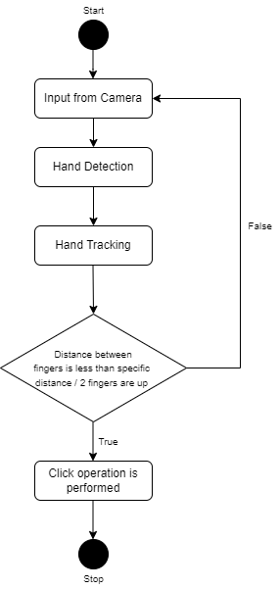

Fig. 5.1. Flowchart for Air Canvas

Figure 5.1 discussed the flow chart of the proposed algorithm. In this algorithm we first acquire the video, extract color from video frame images, apply edge detection and enhancement to detect the object (detect contour) , after that we store X , Y coordinates in deque of respective colors, plot these coordinates and apply optical character recognition (OCR) and display the output on screen.

VI. IMPLEMENTATION

The Existing system, is real time video based fingertip tracking and recognizing algorithm is presented. The system comprises two major tasks: first it detects the motion of colored fingers in video sequence and then applies OCR (Optical Character Reorganization) in order to recognize the plotted image and result is displayed on the screen.

The present system made use of our hand that acts as a virtual mouse that can perform similar operations that a normal manual mouse does without touching the system.The system used hand posture recognition technique to track the movement of hand and then perform various events like click, drag using different finger movements.

The current system uses pattern projector technique to represent the image of the manual keyboard. Thus, the image is projected on flat surfaces. This projected image is similar to that of a manual QWERTY keyboard, with all the keys and control functions as in the keyboard. Here the projector itself takes the input, providing dual functionally. A sensor or camera in the projector picks up finger movements, and passes the information on sensor modules. A virtual keyboard system based on a true-3D optical range camera is presented. Keystroke events are accurately tracked independently on the user and output is displayed on the screen.

But any of the above mentioned modules does not provide all these three functionality in one single system.So we are designing a system that will provide all the above mentioned features in one single application.

**The Experimentational Result of Air Canvas obtained is shown below:**

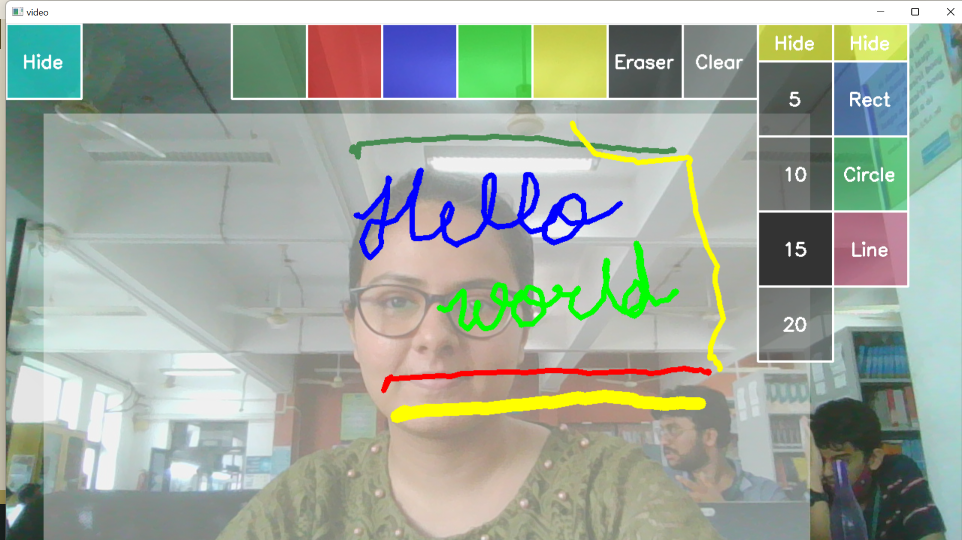

Fig. 6.1. Demonstration of Air Canvas

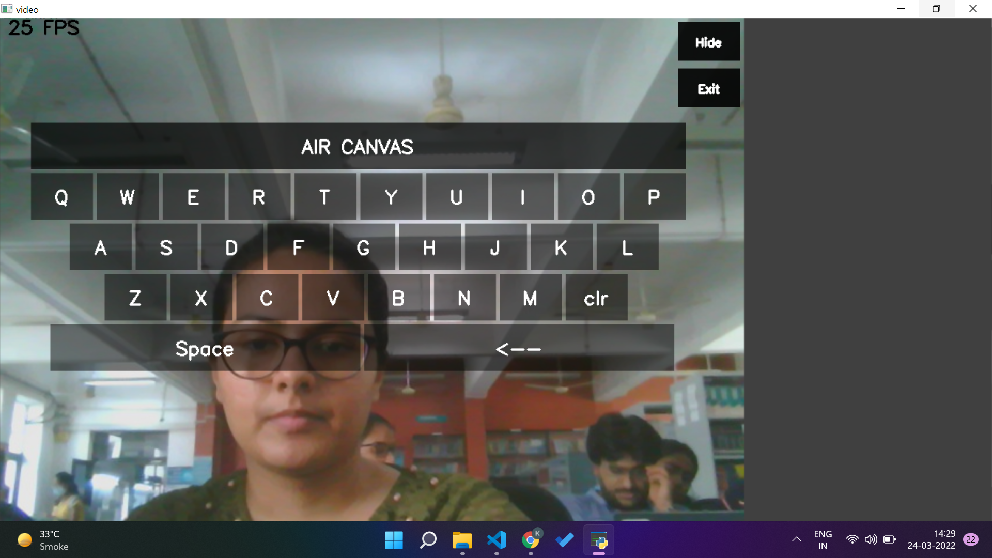

Fig 6.2 Demonstration of Keyboard

In the above fig.6.1, we see the demonstration of our project where a colored marker or object is used by holding it in the hand and four colors are shown as well as a clear button is also displayed which is used to erase the sketch, along with it a sample virtual sketch is displayed on the output screen.

VII. CONCLUSION

The coming era is that of smart tech and tools like Air Canvas and Virtual Computer Systems hold the capacity to replace or overcome the inefficiency and loopholes of conventional systems with increasing demand and developing technology. This will not only save space and time but also improve human-machine interaction and bring better quality of life. The evolution can be as big as making the devices user friendly even for the disabled.

The system can be a tremendous software program for clever wearables the usage of which human beings may want to have higher interaction with the virtual world. In this System, we advanced a digital Computer Application inclusive of mouse, keyboard manipulation together with a Digital Art tool as Air Canvas. But There continues to be the scope and want for growing the efficiency, speed, decreasing time complexity, and addition of a few high-quality features.

VII. FUTURE SCOPE

The scalability scope in software engineering has always been immense, talking about this project here are some of the future scopes we would like to take up and present:

* 1. Further this technology can be extended to home automation by controlling switch boards such as lights on or off with the gesture.
  2. Text to Speech feature- specially designed for physically impaired.
  3. Keyword to image (from web) for better demonstration of concepts and ideas.
  4. Build Robotic arms and other useful objects which can be visually controlled using gestures.
  5. 3D view and rotation of the objects with the help of which Augmented reality of 3D objects can be achieved.
  6. Features such as enlarging and shrinking windows, closing windows, by using the palm and multiple fingers.
  7. Voice recognition keyboard.
  8. Chatbot-for demonstration and assistance.

##### VIII. REFERENCES

[1] Saoji, S. U., et al. "AIR CANVAS APPLICATION USING OPENCV AND NUMPY IN PYTHON." (2021).

[2] Baig, Faisal, Muhammad Fahad Khan, and Saira Beg. "Text writing in the air." Journal of Information Display 14.4 (2013): 137-148.

[3] Yash Patil, Mihir Paun, Deep Paun, Karunesh Singh, Vishal Kisan Borate, "Virtual Painting with Opencv Using Python", International Journal of Scientific Research in Science and Technology (IJSRST), Online ISSN : 2395-602X, Print ISSN : 2395-6011, Volume 5 Issue 8, pp. 189-194, November-December 2020.

[4] Riza Sande, Neha Marathe, Neha Bhegade, Akanksha Lugade, Prof. S. S. Jogdand “Virtual Mouse using Hand Gestures “ International Journal of Advanced Research in Science, Engineering and Technology Vol. 8, Issue 4 , April 2021

[5]Jain, Ayush, and Monika Verma. "An Implementation of Virtual Reality Application of Cursor Control Using Webcam.

[6] Gupta, Dipankar, et al. "An Interactive Computer System with Gesture-Based Mouse and Keyboard." International Conference on Intelligent Computing & Optimization. Springer, Cham, 2020.

[7] Thomas, Joseph. "A Camera Based Virtual Keyboard with Touch Detection by Shadow Analysis.’ (2013).

[8] Nikhil Koul Pranav Nawathe Pranav Tulpule “Virtual Keyboard” International Journal of Scientific & Engineering Research, Volume 5, Issue 4, April-2014 650 ISSN 2229-5518

[9] Wijewantha, Nadeeka Samanthi, and Chanaka Amarasekara. "VistaKey: A Keyboard Without A Keyboard–A Type Of Virtual

Keyboard." Final year project thesis, Informatics Institute of Technology, Wellawatta, Sri Lanka (2004).

[10] Varun, Kollipara Sai, I. Puneeth, and T. Prem Jacob. "Virtual Mouse Implementation using OpenCV." 2019 3rd International Conference on Trends in Electronics and Informatics (ICOEI). IEEE, 2019.

[11] Pranavi Srungavarapu, Eswar Pavan Maganti, Srilekkha Sakhamuri, Sai Pavan Kalyan Veerada, Anuradha Chinta “Virtual Sketch using OpenCV” International Journal of Innovative Technology and Exploring Engineering (IJITEE) ISSN: 2278-3075 (Online), Volume-10 Issue-8, June 2021

[12] Chetan Chilhate, Priyanka D Patharwat, Shriyanka Agarwal, Vivek, Prof. Gauri. S. Bhange “Human Computer Interface Based Virtual Mouse” Vol-3 Issue-2 2017 IJARIIE-ISSN(O)-2395-4396